BOOKING FORM 

**5 Star Non-Shifting Package**

|  |
| --- |
| **Lead of family are to fill in the following form for Hajj 2022/1443 H**  Deposit of**£1500** per pilgrim and passport copies will be needed for submission to be complete. |
|  | |
|  | |

**Number of Pilgrims**

**Name of the Lead Passenger Title**

**14 Days 16 Days 21 Days**

**Booking Ref:**

(Admin only)

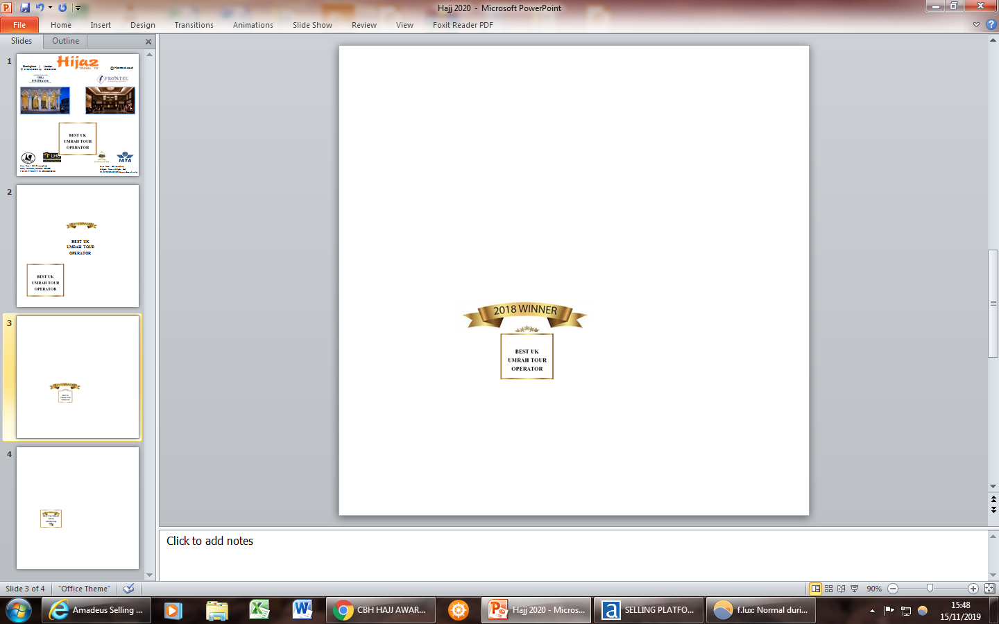

**Full name**

**Email**

**Mobile Number**

**Home Number**

**Emergency Contact Number**

**Address**

**Address**

**Barclays Bank**

**Account Name:** Hijaz Travel Ltd

**Sort Code:** 20-08-98 **Account Number:** 83084450

**Are there any medical condition / Special request? Bank Details for Payment**

**Title Full name Relation to the lead passenger**

**Postcode**

**City**

**Hijaz Travel Ltd (London)**

**M: 07930561289 (Appointment only)**

**hijaztravel.co.uk**

**Signature Date**

**Declaration**

**I am signing below that I am responsible as lead passenger to inform all members in my booking the terms and conditions and accept that all members will adhere to them along with providing any relevant documentation to acquire their visas.**

**I have read and understood the terms and conditions of Hijaz Travel Ltd and have answered to the best of my knowledge. I declare that if I have travelled to the Kingdom of Saudi Arabia under a Hajj Visa in the last five years (since Hajj 2013) I may be charged an extra 2000 SR on top of my package. Please note above prices are excluding any new fees or taxes applied by Saudi / UK authorities.**

**I accept the terms and conditions set by Hijaz Travel Ltd and understand that the package is subject to changes.**

**I have given all passport copies at this time to a representative of Hijaz Travel Ltd and I have understood that I am responsible to submit valid passports upon Hijaz Travel Ltd request for submission to the embassy.**

**If wheelchair is needed please state & notify any Hijaz Travel Ltd Support Team member. We will look into your request and inform you when we are confirming your booking.**

**Documentation required for processing package Hajj visa:**

1. i) All passports should be valid for seven month on the day of travel.
   1. European passport holders will need to provide a utility bill and bank statement to confirm their address

iii) Non-European passport holders will need to have a valid UK residency permit or visa with minimum seven-month validity from the date of travel

1. 2 x recently taken passport sized photos with white background only.
2. Vaccination certificate: Meningitis (ACWY) per pilgrim.
3. Valid PCR test certificate, Proof of double dose Covid 19 vaccine NHS latter

**Family Members**

**Hijaz Travel Ltd (Birmingham)**

**558A Coventry Rd, B10 0UN**

**T: 0121-7738777 M: 07800592508**